**CAT COMMANDS:-**

1. cat ( to show directory’s inside ):-

{ First-directory name ,Hello – inside directory file }

2.cat –A:-



3.cat –b:-

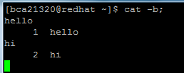

4.cat –e:-

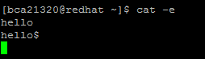

5. Cat –E:-



6. Cat –n:-

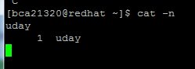

7.cat –s:-

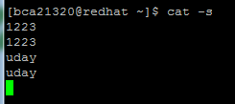

8. Cat –T:-

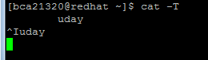

9. Cat –v:-

